Research on Thyroid Disease Analysis

Dataset Overview

The dataset used for the research is the “Thyroid Disease Patient” dataset which captures various attributes related to thyroid conditions for medical diagnosis. It includes demographic information such as age and sex. Medical history features encompass intake of thyroxine, antithyroid medications, and past surgeries. Patients' current health status regarding sickness, pregnancy, presence of goiter, tumor, or hypopituitary conditions is recorded. Additionally, it notes whether patients suspect hypothyroidism or hyperthyroidism. Laboratory results like TSH, T3, TT4, T4U, and FTI levels are included if measured. Result denotes the presence or absence of hyperthyroidism. Referral sources are indicated as well. This dataset is collected from Kaggle.com, owner named Prakhar Kapoor. The source link of the dataset and overview is given below:

Source: https://www.kaggle.com/datasets/kapoorprakhar/thyroid-disease-patient-dataset

Feature Analysis Table

NO | Columns | Description
1 | age | age of the patient.
2 | sex | sex patient identifies.
3 | on_thyroxine | whether patient is on thyroxine.
4 | query_on_thyroxine | whether patient believes they are on thyroxine.
5 | on_antithyroid_meds | whether patient is on antithyroid meds.
6 | sick | whether patient is sick .
7 | pregnant | whether patient is pregnant.
8 | thyroid_surgery | whether patient has undergone thyroid surgery .
9 | I131_treatment | whether patient is undergoing I131 treatment .
10 | query_hypothyroid | whether patient believes they have hypothyroid.
11 | query_hyperthyroid | whether patient believes they have hyperthyroid.
12 | lithium | whether patient has lithium.
13 | goitre | whether patient has goitre.
14 | tumor | whether patient has tumor.
15 | hypopituitary | whether patient has hyperpituitary gland.
16 | psych | whether patient has psych .
17 | TSH_measured | whether TSH was measured in the blood .
18 | TSH | TSH level in blood from lab work .
19 | T3_measured | whether T3 was measured in the blood.
20 | T3 | T3 level in blood from lab work .
21 | TT4_measured | whether TT4 was measured in the blood.
22 | TT4 | TT4 level in blood from lab work .
23 | T4U_measured | whether T4U was measured in the blood .
24 | T4U | T4U level in blood from lab work .
25 | FTI_measured | whether FTI was measured in the blood.
26 | FTI | FTI level in blood from lab work.
27 | TBG_measured | whether TBG was measured in the blood.
28 | TBG | TBG level in blood from lab work.
29 | referral_source
30 | Result | hyperthyroidism medical diagnosis.

Characteristic Table
Dataset  Characteristics: | Attribute  Characteristics: | Number of Instances: | Number of Attributes:
Multivariate, Imbalanced | Numerical: 6 & Categorical: 23 | 3770 | 30

Class Label : Result attribute has two classes: ‘P’ and ‘N’ with 3479 Positive values and 291 Negative values which refers to 92.3% and 7.7% ratio respectively. That means our dataset is highly imbalanced where the Positive class is dominating.

CompletedData Analysis & Preprocessing

- Dataset has a shape of 3770 data and 30 attributes. 7 attributes are numerical and 23 are categorical attributes.
- Unique values for each attribute were shown and mean,median and mode were calculated.
- Data distribution plots have shown that ‘T3’, ‘T4’ and ‘T4U’ have normally distributed data as their mean was almost equal to median, ‘TSH’ has positively skewed data as mean was greater than median, ‘Age’ and ‘FTI’ have negatively skewed data since mean was less than median.
- Categorical data were plotted using barplot.
- Scatterplot shown pairwise distribution of numerical columns distinguished by ‘sex’.
- Frequencies of each unique value have been shown for each attribute.
- Variance showed the variability of data that means how much the range of data is.’T3’ and ‘T4U’ have low variance. ‘Age’, ‘TSH’, ‘T4’ and ‘FTI’ have high variance which indicates overfitting which works poorly in test data.
- Only the ‘sex’ and ‘TBG’ attributes have missing values.
- 7 attributes have been dropped due to irrelevancy. ‘TBG’ attribute was an empty column and we don’t need an attribute without data. 'TSHmeasured', 'T3measured', 'TT4measured', 'T4Umeasured', 'FTImeasured', 'TBGmeasured' attributes contained unnecessary information. Since we can know the value from the test attributes ‘TSH’, ‘T3’, ‘TT4’, ‘T4U’, ‘FTI’ whether tests were taken or not, we don’t need those attributes. ‘Age’ attribute has a faulty data 455 so we dropped that also.
- ‘Sex’ attribute contained 150 missing values. We filled the missing cells using mode as the attribute is categorical.
- 63 duplicate data have been dropped.
- Outliers have been detected using Z score and Modified Z score. Features which were normally distributed (‘T3’, ‘T4, and ‘T4U’) used the Z score method as it is mean based and the skewed features (‘Age’, ‘TSH’ and ‘FTI’) used Modified Z score because it computes the median. 56 outliers were detected using Z score and Modified Z score found 12 outliers. Combining those the dataset has a total of 62 outliers.
- Summary of the preprocessed dataset was created and shown. It shows that the preprocessed dataset contains 3672 data and 23 attributes.
- Object type data were converted to numerical values using LabelEncoder where we needed to classify.

CompletedCorrelation

Numerical Features

Several correlation methods have been used to find the significance of numerical features (‘Age’, ‘T3’, ‘T4’, ‘T4U’ and ‘FTI’). They are Pearson, Spearman, Kendall and Logistic Regression.

- Pearson Coefficient: Pearson correlation coefficient (PCC) is a correlation coefficient that measures linear correlation between two sets of data. The coefficient r can be defined as:
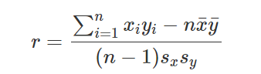
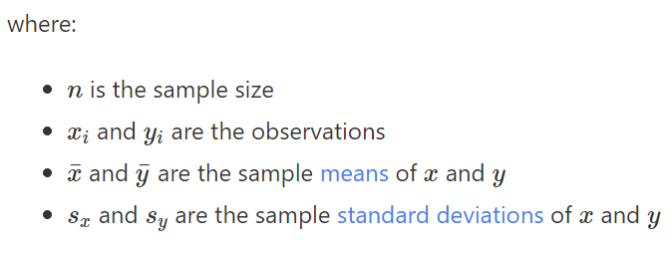

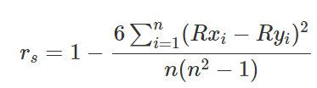
- Spearman Rank Coefficient: It measures the strength and direction of the association between two ranked variables. The coefficient r can be defined as where R means the rank of data:
- Kendall Coefficient: It is measured by the similarity of the orderings of the data when ranked by each of the quantities. The coefficient τ can be defined as:
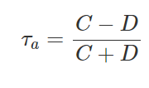
where:

- C is the number of concordant pairs
- D is the number of discordant pairs

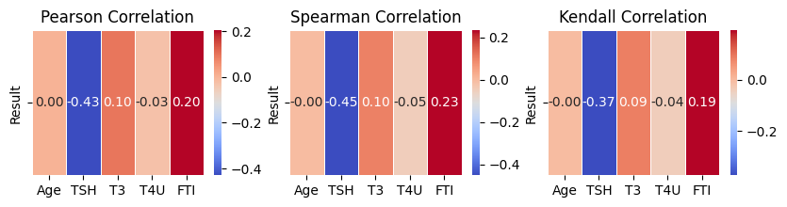

The most significant attribute is 'TSH' with a correlation coefficient of -0.43(Pearson), -0.45(Spearman). and -0.37(Kendall). The second most significant attribute is 'FTI' with a correlation coefficient of 0.2(Pearson), 0.23(Spearman). and 0.19(Kendall)

- Logistic Regression: To determine the correlation between numerical features and categorical class attribute logistic regression has been used. Parameters used to determine significance were: Coefficients(the change in the log-odds of the outcome variable), Standard Errors, Z-scores, P-values(significance of coefficient), LL-Null(log likelihood), Covariance Type, LLR p-value(likelihood ratio) and Converged. P value <0.05 indicates more significance, positive coefficient indicates positive effect, Z score>1.96 indicates high significance. Based on these conditions ‘TSH’ is the most significant numerical feature. Also ‘T3’ and ‘FTI’ are more significant than the rest of the numerical features.
- Chi Square Test: To determine the correlation between categorical features and categorical class attribute Chi square test has been used. Parameters used to determine significance were: Contingency table Expected frequency, Chi square statistics, P-values(significance of coefficient),Degree of freedom(number of independent observations). Larger chi square and Phi coefficient value indicates strong correlation, P value <0.05 indicates more significance. Based on these conditions ‘sex’, ‘thyroxine’, ‘query_hypothyroid’and ‘referral_source’ are the most significant categorical features.

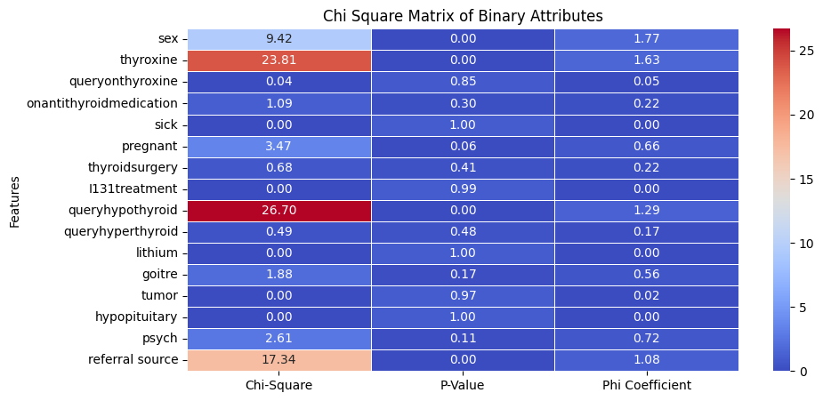
Classification Metrics:

Accuracy: The proportion of correctly classified instances (both true positives and true negatives) out of the total instances.
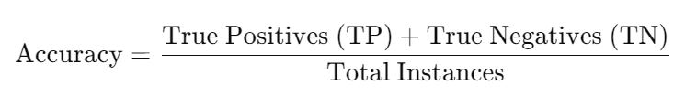
Precision: The proportion of correctly predicted positive instances out of all instances predicted as positive. It measures how many of the predicted positives are actually positive.
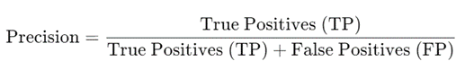

Negative Predictive Value (NPV): It measures the proportion of correctly predicted negative instances out of all instances predicted as negative.

Recall/Sensitivity: The proportion of actual positives that are correctly identified (also known as true positive rate).
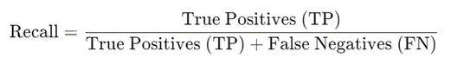

Specificity: The proportion of actual negatives that are correctly identified (also known as true negative rate).
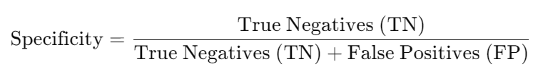

False Positive Rate (FPR): The proportion of actual negatives that are incorrectly classified as positives. It is complementary to specificity.
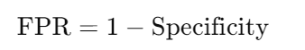

F1-Score: Harmonic mean.
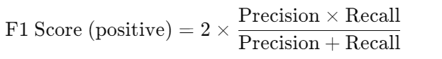
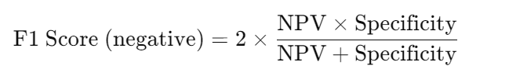

Geometric Mean (G-Mean): The geometric mean of sensitivity and specificity, often used to measure the balance between classification performance on the positive and negative classes.
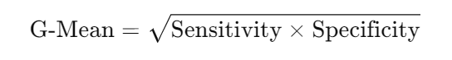

CompletedSVM Classification

SVM classification classifies data using support vectors and decision boundaries. It is to find the optimal hyperplane that can separate the data points in different classes in the feature space. The hyperplane tries to make the margin between the closest points of different classes should be as maximum as possible.The dataset was split into 80:20 ratio which made 2937 train data and 735 test data. The best parameter found for our dataset was the linear kernel which has the function K(w,b) = wT(x+b) and C=100 was set as the regularization parameter. Using the stratified k fold the average accuracy was 97.58%.Average classification:

precision recall f1-score support
0 0.93 0.74 0.83 58
1 0.98 0.99 0.98 676

Although the precision for class 0 is perfect, recall and f1-score is not satisfactory. As it is an imbalanced dataset having a minority class ‘Negative’, the model works poorly in this class.

CompletedSMOTE

One way to handle this imbalance problem is to balance the dataset. SMOTE(Synthetic Minority Over-sampling Technique) increases the minority class data by creating synthetic value using k nearest neighbors. Rather than duplicating it creates new data to balance the dataset. Our dataset now has 5402 training data consisting of equal class values. Here the best parameter for the balanced dataset using SVM was linear kernel and C=10 was set as the regularization. Accuracy was 98.37% and Classification Report:

precision recall f1-score support
0 0.86 0.93 0.89 55
1 0.99 0.99 0.99 680

The recall, f1-score have improved than SVM but precision has decreased for class 0 and the recall has decreased slightly for class 1. Also it is not an optimal solution to address the imbalance challenge as the new data are not real but synthetic.

CompletedFuzzy SVM

Fuzzy SVM is a hybrid classification model that can solve the cons of traditional SVM classifiers. In SVM, each data is treated equally but for an imbalanced dataset like ours this can be a problem as the minority class data doesn’t get enough attention. As a result the performance is poor. Fuzzy SVM incorporates Fuzzy logic in classification to handle uncertain data and increase certainty.. It gives fuzzy membership to each data that decides the influence of that data on the prediction. To enhance the performance of an imbalance dataset, higher membership is assigned to minority class data in the training set. It is better than SMOTE since it doesn’t include new or duplicate data but works with original data and gives more attention to the minority class data. Parameters used in this method:

- For best results Stratified K fold has been used having 5 folds.
- Custom FuzzySVM model was implemented.
- Model was fitted by adjusting weights where weight = C*Fuzzy membership.
- Fuzzy membership was assigned to the class label data. Positive class was assigned 1 and Negative class was assigned 1.5.
- Average accuracy was 98.28% for rbf kernel and C=100 and the average classification:

precision recall f1-score support
0 0.90 0.87 0.89 58
1 0.99 0.99 0.99 677

- Fuzzy membership was assigned using inverse sigmoid function. Positive class was assigned 0.27 and Negative class was assigned 0.5.

- Average accuracy was 97.96% for rbf kernel and C=100 and the average classification:

precision recall f1-score support
0 0.87 0.87 0.87 58
1 0.99 0.99 0.99 676

- Accuracy is slightly better than SVM. Overall precision is as good as SVM but the recall and f1-score are highly improved.

CompletedEnsemble

Ensembling gives better predictive performance by combining the predictions from multiple models. Bagging, Stacking and Boosting are three methods and we used a boosting method since it is more effective than bagging and less complex than stacking. Also used a hybrid ensemble of different classifiers to use the strength of each classifier. Here we used two types of ensembling:

XGBoosting: XGBoosting algorithm works by iteratively training decision trees to correct the errors of the previous trees to minimize the loss function using gradient descent. It works on improving loss function and correcting misclassification.
- RMSE regularization was used to calculate loss function and histogram based trees were constructed to speed up the process for the large dataset.
- 20 rounds of boosting were set and the best iteration was set from the lowest loss function for the validation set for each fold.
- Model was trained using the best iteration value found in each fold and a binary logistic objective function was set for classification.
- Average accuracy was 99.46% and the average classification:

precision recall f1-score support
0 0.97 0.96 0.96 58
1 0.99 1.00 0.98 677

Hybrid Ensemble: Combination of different classifiers are used to classify data. Three classifiers NB, KNN and SVM were combined together using a voting ensemble to improve overall performance.

- For ‘Soft Voting’ which works using probabilities of prediction, average accuracy was 95.56% and the average classification:
precision recall f1-score support
0 0.87 0.51 0.64 58
1 0.96 0.99 0.97 676

- For ‘Hard Voting’ which takes majority prediction of classifiers, average accuracy was 95.97% and the average classification
precision recall f1-score support
0 0.89 0.55 0.68 58
1 0.96 0.99 0.98 676

Ensemble | Fuzzy SVM
XGBoosting: XGBoosting algorithm works by iteratively training decision trees to correct the errors of the previous trees to minimize the loss function using gradient descent.  - Average accuracy was 99.46% and the average classification:  precision recall f1-score support  0 0.97 0.96 0.96 58  1 0.99 1.00 0.98 677 | Discrete Function: This assigns constant value according to class. 1 is assigned to positive class and 1.5 is assigned to negative class as it is minor. This gives.  - Average accuracy was 98.28% for rbf kernel, gamma 100 and C=100 and the average classification:  precision recall f1-score support  0 0.90 0.87 0.89 58  1 0.99 0.99 0.99 677
Hybrid Ensemble: Three classifiers NB, KNN and SVM were combined together using a voting ensemble.  - For ‘Soft Voting’ which works using probabilities of prediction, average accuracy was 95.56% and the average classification:  precision recall f1-score support  0 0.87 0.51 0.64 58  1 0.96 0.99 0.97 676  - For ‘Hard Voting’ which takes majority prediction of classifiers, average accuracy was 95.97% and the average classification  precision recall f1-score support  0 0.89 0.55 0.68 58  1 0.96 0.99 0.98 676 | Exponential Function: 1 / (1 + np.exp(y)) function was used to assign higher membership to minority class.  - Average accuracy was 97.96% for rbf kernel and C=100 and the average classification:  precision recall f1-score support  0 0.87 0.87 0.87 58  1 0.99 0.99 0.99 676
CompletedFuzzy SVM(Distance Based)

In the existing FSVM-CIL method, membership values are assigned for training examples in such a way to satisfy the following two goals:
1) to suppress the effect of between class imbalance
2) to reflect the within-class importance of different training examples in order to suppress the effect of outliers and noise. These membership functions as follows:

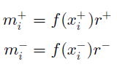
Where,

- m = membership value.
- f(xi) = fuzzy membership function for xi train sample.
- r = ratio. To assign higher membership minority class, r = 1 for minority class and r = minority/majority ratio for majority class. f(xi) is assigned using different methods:

Based on the Distance from the Own Class Center: In this method, f(xi) is defined with respect to the distance between xi and its own class center The examples closer to the class center are treated as more informative and assigned higher f(xi) values, while the examples far away from the center are treated
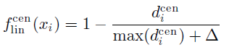
as outliers or noise and assigned lower f(xi) values.

Linear function adding Δ a small positive value to avoid 0.
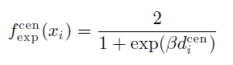

Exponential function including β which determines steepness of the decay.

Based on the Distance from the Actual Hyperplane:In this method, we define f(xi) based on the distance from the actual separating hyperplane to xi , which is found by training a conventional SVM model on the imbalanced dataset. The examples closer to the actual separating hyperplane are treated as more informative and assigned higher membership values, while the examples far away from the separating hyperplane are treated as less informative and assigned lower membership values.
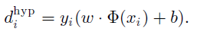
Margin of data from hyperplane.
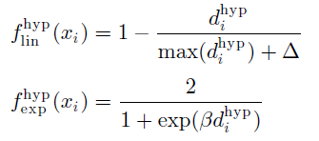

Linear and exponential functions.

CompletedProposed Approach(Distance from the Feature Threshold):

The previous membership functions used distance from class center which did not focus on data that are highly risky to be misclassified. Hyperplane based distance performed very well for an imbalance dataset but it used an SVM classifier which made the computation complex. Limitations of these methods are:

- Class Center: The method calculates distances from each sample to its respective class center and normalizes these distances. However, it treats each class's distance equally without considering the imbalance in class distributions. In heavily imbalanced datasets, this can lead to disproportionate contributions to membership values from the majority class, potentially overshadowing the minority class.
- Hyperplane: SVM classifier is mainly used for classification and to improve imbalance learning fuzzy membership is added. The method heavily relies on the performance and output of the SVM classifier. If the SVM model does not perform well (e.g., due to overfitting, underfitting, or inappropriate kernel choice), it can affect the quality of the distance calculations and, consequently, the fuzzy membership values.

Feature Based Distance: To overcome these limitations, feature based fuzzy membership can be used. In this method two most significant features are chosen, which in this case are ‘TSH and ‘FTI’. The significance is determined from correlation methods which indicate ‘TSH’ as the most significant property to influence ‘Result’ class. ‘FTI’ was found to be the second most significant feature. Distance from feature is calculated as:
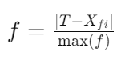
Where,
- T = threshold value of feature which can separate data into binary class. For ‘TSH’ f = 5 and for ‘FTI’ f = 100.
- Xfi denotes the i-th element in the feature Xi data.
- max⁡(f) represents the maximum value among the elements of feature to normalize.
Linear Function:

membership=(α⋅(1−f1_contribution))+(β⋅(1−f2_contribution))

Where, α and β determine the contribution weight of each feature. f1_contribution = ‘TSH’ based distance which is most significant so α is set to 1. β is set to 0.7.

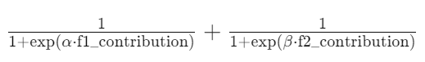
Exponential Function:

membership = α and β determine the steepness of decay.

Result:

Classifier | Accuracy | Class | Precision | Recall | F1 Score
SVM | 96.19% | 0 | 0.84 | 0.64 | 0.77
SVM | 96.19% | 1 | 0.97 | 0.99 | 0.99
FSVM(Center-lin) | 96.49% | 0 | 0.71 | 0.95 | 0.81
FSVM(Center-lin) | 96.49% | 1 | 0.99 | 0.97 | 0.98
FSVM(Center-exp) | 93.93% | 0 | 0.61 | 0.76 | 0.66
FSVM(Center-exp) | 93.93% | 1 | 0.98 | 0.96 | 0.97
FSVM(Hyper-lin) | 96.38% | 0 | 0.70 | 0.95 | 0.81
FSVM(Hyper-lin) | 96.38% | 1 | 0.99 | 0.96 | 0.98
FSVM(Hyper-exp) | 96.43% | 0 | 0.71 | 0.94 | 0.81
FSVM(Hyper-exp) | 96.43% | 1 | 0.99 | 0.97 | 0.98
FSVM(Feature-lin) | 96.60% | 0 | 0.72 | 0.94 | 0.81
FSVM(Feature-lin) | 96.60% | 1 | 0.99 | 0.97 | 0.98
FSVM(Feature-exp) | 97.11% | 0 | 0.75 | 0.96 | 0.84
FSVM(Feature-exp) | 97.11% | 1 | 0.99 | 0.97 | 0.98

Discussion:

From the above result analysis of existing SVM, FSVM model and proposed Fuzzy SVM, it can be seen that the both feature based membership functions have better performance than the best FSVM(Center-lin). FSVM(Feature-exp) has the best accuracy while the FSVM(Feature-lin)

Reference

SMOTE:
SMOTE for Imbalanced Classification with Python - MachineLearningMastery.com

Ensemble:
A Gentle Introduction to Ensemble Learning Algorithms - MachineLearningMastery.comMachine Learning concept 53: XGBoosting & Adaboosting. | by Chandra Prakash Bathula | MediumLearn XGBoost in Python
Early Thyroid Risk Prediction by Data Mining and Ensemble Classifiers
Prediction of Thyroid Disease using Machine Learning Approaches and Featurewiz Selection | Journal of Telecommunication, Electronic and Computer Engineering (JTEC)
Prediction of Hypothyroidism and Hyperthyroidism Using Machine Learning Algorithms
Explainable artificial intelligence and machine learning algorithms for classification of thyroid disease
Hybrid Classifier Ensemble for Imbalanced Data

Fuzzy SVM:
New Fuzzy Support Vector Machine for the Class Imbalance Problem in Medical Datasets Classification - Gu - 2014 - The Scientific World Journal - Wiley Online Library
FSVM-CIL: Fuzzy Support Vector Machines for Class Imbalance Learning | IEEE Journals & Magazine

